A PROJECT REPORT ON

Personal portfolio Website

A Report Submitted to

IIDT - Blackbuck Engineers Pvt. Ltd

Submitted By:

Dikshya Singh

22781A05J3

## Acknowledgement

We extend our sincere gratitude to everyone who supported the completion of this project. Special thanks to SVCET for their insightful guidance and encouragement throughout the development process. We also appreciate the collaborative efforts of myself and my team members, whose contributions were invaluable. Our appreciation goes to IIDT - Blackbuck Engineers Pvt. Ltd for providing the resources and support needed. Finally, we thank our families and friends for their unwavering encouragement.

## Abstract

This project involves the development of a personal portfolio website designed to showcase individual skills, projects, and contact information. The website features a responsive navigation menu, a typing effect for displaying skills, and scroll animations for a dynamic user experience. The project leverages modern web technologies such as HTML, CSS, and JavaScript, including libraries like Typed.js and Scroll Reveal. The primary goal is to create an engaging and visually appealing portfolio that enhances personal branding.

## Introduction

In today’s digital age, a personal portfolio website is a crucial tool for professionals to showcase their work and skills. This project addresses the need for a well-designed, responsive portfolio site. The website includes various features such as a dynamic navigation menu, animations, and interactive elements to provide a compelling user experience. The project aims to demonstrate proficiency in frontend development and create a platform for personal branding.

## Advantages

1. **Responsive Design**: The website adapts to different screen sizes, ensuring a seamless experience on both desktop and mobile devices.
2. **Interactive Features**: Includes dynamic elements like a typing effect and scroll animations to engage users.
3. **User-Friendly Navigation**: The navigation menu is easy to use and closes automatically when a menu item is clicked, enhancing usability.

## Disadvantages

1. **Performance Overhead**: Advanced animations and effects may impact performance on lower-end devices.
2. **Browser Compatibility**: Some CSS and JavaScript features may not work consistently across all browsers.
3. **Maintenance**: Regular updates may be required to keep the website functioning optimally with new web technologies.

## Software and Hardware Requirements

### Software Requirements

* **Operating System**: Windows 10, macOS Big Sur, or any modern OS.
* **Web Browser**: Google Chrome, Mozilla Firefox, or any modern browser.
* **Development Tools**: Visual Studio Code or any code editor, Git for version control.
* **Libraries/Frameworks**: Typed.js for typing effects, ScrollReveal for animations.

### Hardware Requirements

* **Processor**: Intel i5 or equivalent.
* **RAM**: 8 GB or more.
* **Storage**: 256 GB SSD or more.
* **Network**: Stable internet connection for development and testing.

## Motivation

The motivation behind this project is to create a visually appealing and functional personal portfolio website that effectively showcases skills and projects. With increasing competition in the job market, having a standout portfolio is essential for making a strong impression. This project aims to provide a comprehensive platform that highlights individual achievements and capabilities.

## Literature Review

The literature review includes relevant studies and resources on web development and design principles:

1. **"Responsive Web Design"** by Ethan Marcotte - Discusses the principles of responsive design and its importance for modern websites.
2. **"JavaScript and JQuery: Interactive Front-End Web Development"** by Jon Duckett - Covers JavaScript and JQuery techniques for creating interactive web elements.
3. **"CSS Secrets: Better Solutions to Everyday Web Design Problems"** by Lea Verou - Provides insights into advanced CSS techniques for enhancing website design.

These sources offer foundational knowledge and best practices for implementing the features in this project.

## Existing System

Existing portfolio websites often include:

1. **Simple Static Pages**: Basic HTML and CSS-based portfolios with minimal interactivity.
2. **Template-Based Portfolios**: Pre-designed templates that users can customize, offering limited flexibility.
3. **Dynamic Portfolios with CMS**: Portfolios integrated with Content Management Systems (CMS) like WordPress, providing easy content updates but often lacking in design uniqueness.

Despite their advantages, these systems may not always offer the level of customization or interactivity desired.

## Proposed System

The proposed system addresses the limitations of existing portfolio websites by incorporating:

1. **Responsive Navigation Menu**: Ensures usability across devices with a responsive design.
2. **Typing Effect**: Adds a dynamic element to showcase skills in a visually engaging manner.
3. **Scroll Reveal Animations**: Enhances user experience by animating content as it comes into view.

These features aim to create a more engaging and personalized portfolio experience.

## Keywords and Definitions

* **Responsive Design**: Design approach that ensures a website functions well on various devices and screen sizes.
* **Typing Effect**: An animation that simulates text being typed out on screen.
* **Scroll Reveal**: A JavaScript library for animating elements as they scroll into view.

## Implementation

The implementation of the project involves:

1. **Frontend Development**: Building the user interface using HTML, CSS, and JavaScript.
2. **Feature Integration**: Adding interactive elements such as the typing effect and scroll animations.
3. **Testing and Optimization**: Ensuring the website performs well across different devices and browsers.

## Challenges Faced

1. **Performance Issues**: Animations and effects may impact performance on older devices. Solution: Optimized animations and implemented fallback options.
2. **Cross-Browser Compatibility**: Ensuring consistent behavior across different browsers. Solution: Used polyfills and tested on multiple browsers.
3. **Responsive Design**: Achieving a seamless experience on various screen sizes. Solution: Implemented media queries and flexible layouts.

## System Testing

### Unit Testing

Unit tests were conducted for individual components to ensure they function correctly:

1. **Navigation Menu**: Tested responsiveness and functionality.
2. **Typing Effect**: Verified proper execution and timing.

### Integration Testing

Integration tests focused on interactions between components:

1. **Menu and Content**: Ensured the menu links correctly navigate to different sections.
2. **Animations and User Interaction**: Verified that animations trigger appropriately on user actions.

### Performance Testing

Performance tests evaluated the website’s performance under different conditions:

1. **Load Time**: Measured time to load the website on various devices.
2. **Responsiveness**: Tested the website’s responsiveness under different network speeds.

### Acceptance Testing

Acceptance testing ensured the website met user requirements:

1. **Functionality**: Verified that all features work as expected.
2. **Usability**: Assessed user experience and ease of navigation.

## Test Results

* **Unit Test Results**: All individual components performed as expected with minor issues addressed.
* **Integration Test Results**: Smooth interaction between components with all integrations functioning correctly.
* **Performance Test Results**: The website performed well under normal conditions, with optimizations in place for performance issues.
* **Acceptance Test Results**: User feedback was positive, with all requirements met.

**Coding:**

**Index.html**

 <!DOCTYPE html>

<html lang="en">

<head>

    <meta charset="UTF-8">

    <meta name="viewport" content="width=device-width, initial-scale=1.0">

    <title>Portfolio | Dikshya </title>

<!-- UNICONS -->

    <link rel="stylesheet" href="https://unicons.iconscout.com/release/v4.0.8/css/line.css">

    <!-- LINK CSS -->

    <link rel="stylesheet" href="assets/css/style.css">

</head

<body>

    <div class="containeer">

        <!-- HEADER -->

        <nav id="header">

            <div class="nav-logo">

                <p class="nav-name">Dikshya</p>

                <span>.</span>

            </div>

            <div class="nav-menu" id="myNavMenu">

                <ul class="nav-menu-list">

                    <li class="nav-list">

                        <a href="#home" class="nav-link active-link">Home</a>

                        <div class="circle"></div>

                    </li>

                    <li class="nav-list">

                        <a href="#about" class="nav-link">About</a>

                        <div class="circle"></div>

                    </li>

                    <li class="nav-list">

                        <a href="#projects" class="nav-link">Projects</a>

                        <div class="circle"></div>

                    </li>

                    <li class="nav-list">

                        <a href="#contact" class="nav-link">Contact</a>

                        <div class="circle"></div>

                    </li>

                </ul>

            </div>

            <div class="nav-button">

                <button class="btn">Download CV <i class="uil uil-file-alt"></i></button>

            </div>

            <div class="nav-bar">

                <i class="uil uil-bars" onclick="myMenuFunction()"></i>

            </div>

        </nav>

        <!-- MAIN -->

        <main class="wrapper">

            <!-- HOME BOX -->

            <section class="featured-box" id="home">

                <div class="featured-text">

                    <div class="featured-text-card">

                        <span>Dikshya Singh</span>

                    </div>

                    <div class="featured-name">

                        <p>I'm <span class="typedText"></span></p>

                    </div>

                    <div class="featured-text-info">

                        <p>Learning-phase Developer</p>

                    </div>

                    <div class="featured-btn">

                        <button class="btn blue-btn">Let's connect</button>

                        <button class="btn">Download CV <i class="uil uil-file-alt"></i></button>

                    </div>

                    <div class="social-icons">

                        <div class="icon">

                            <a href="https://www.instagram.com/diksha_066?igsh=dGx3M2M0ZHppOHNq&utm_source=qr">

                                <i class="uil uil-instagram"></i></a>

                        </div>

                        <div class="icon"> <a

                                href="https://www.linkedin.com/in/dikshya-singh-4627231b7?utm_source=share&utm_campaign=share_via&utm_content=profile&utm_medium=ios_app"><i

                                    class="uil uil-linkedin-alt"></i></a></div>

                        <div class="icon"> <a href="https://www.facebook.com/decchya.cingh?mibextid=LQQJ4d"><i

                                    class="uil uil-facebook-f"></i></a></div>

                        <div class="icon"> <a href="https://github.com/DikshyaSingh"><i

                                    class="uil uil-github-alt"></i></a> </div>

                    </div>

                </div>

                <div class="featured-image">

                    <div class="image">

                        <img src="assets/images/dikshya.jpg" alt="avatar">

                    </div>

                </div>

                <div class="scroll-down-btn">

                    <a href="#about" class="scroll-btn">

                        <i class="uil uil-mouse-alt"></i>

                        <p>Scroll Down</p>

                    </a>

              </div>

            </section>

            <!-- ABOUT BOX -->

            <section class="section" id="about">

                <div class="top-header">

                    <h1>About Me</h1>

                </div>

                <div class="row">

                    <div class="col">

                        <div class="about-info">

                            <h3>About Me</h3>

                            <p>As a driven and creative individual, I am excited to embark on a career in front-end web

                                development. While I may not have professional experience yet, I have dedicated

                                significant time to learning essential web development skills through online courses,

                                personal projects, and self-directed study.

                                I am proficient in HTML, CSS, and JavaScript, and I have a strong understanding of

                                responsive web design principles. I enjoy bringing designs to life through clean,

                                semantic code and am passionate about creating engaging user experiences.

                            </p>

                            <div class="about-btn">

                                <button class="btn">Download CV <i class="uil uil-import"></i></button>

                            </div>

                        </div>

                    </div>

                    <div class="col">

                        <div class="skill-header">

                            <div class="skill-box">

                                <h3>Frontend</h3>

                            </div>

                            <div class="skill-list">

                                <span>HTML</span>

                                <span>CSS</span>

                                <span>Bootstrap</span>

                                <span>JavaScript</span>

                                <span>Tailwind CSS</span>

                                <span>React</span>

                            </div>

                        </div>

                        <div class="skill-header">

                            <div class="skill-box">

                                <h3>Backend</h3>

                            </div>

                            <div class="skill-list">

                                <span>PHP</span>

                                <span>Java</span>

                                <span>C++</span>

                                <span>Python</span>

                            </div>

                        </div>

                        <div class="skill-header">

                            <div class="skill-box">

                                <h3>DataBase</h3>

                            </div>

                            <div class="skill-list">

                                <span>MySQL</span>

                                <span>MongoDB</span>

                            </div>

                        </div>

                    </div>

                </div>

            </section>

            <!-- PROJECT BOX -->

            <section class="section" id="projects">

                <div class="top-header">

                    <h1>Projects</h1>

                </div>

                <div class="project-container">

                    <div class="project-box">

                        <i class="uil uil-briefcase-alt"></i>

                        <h3>Completed</h3>

                        <label>5+ finished Projects</label>

                    </div>

                    <div class="project-box">

                        <i class="uil uil-trophy"></i>

                        <h3>Cretificates</h3>

                        <label>10+ Cretificates</label>

                    </div>

                    <div class="project-box">

                        <i class="uil uil-award"></i>

                        <h3>Experience</h3>

                        <label>Learning / Beginner</label>

                    </div>

                </div>

            </section>

            <!-- CONTACT BOX -->

            <section class="section" id="contact">

                <div class="top-header">

                    <h1>Get in touch</h1>

                    <span>Do you have project in your mind, contact

                        me</span>

                </div>

                <div class="row">

                    <div class="col">

                        <div class="contact-info">

                            <h2>Find Me <i class="uil uil-corner-right-down"></i></h2>

                            <p><i class="uil uil-envelope"></i> Email:

                                dikshyasingh99@gmail.com</p>

                            <p><i class="uil uil-phone"></i> Tel: +91

                                8105481545</p>

                        </div>

                    </div>

                    <div class="col">

                        <div class="form-control">

                            <div class="form-inputs">

                                <input type="text" class="input-field" placeholder="Name">

                                <input type="text" class="input-field" placeholder="Email">

                            </div>

                            <div class="text-area">

                                <textarea placeholder="Message"></textarea>

                            </div>

                            <div class="form-button">

                                <button class="btn">Send <i class="uil uil-message"></i></button>

                            </div>

                        </div>

                    </div>

                </div>

            </section>

        </main>

        <!-- FOOTER -->

        <footer class="footer">

            <div class="top-footer">

                <p>Dikshya Singh .</p>

            </div>

            <div class="middle-footer">

                <ul class="footer-menu">

                    <li class="footer-menu-list">

                        <a href="#home">Home</a>

                    </li>

                    <li class="footer-menu-list">

                        <a href="#about">About</a>

                    </li>

                    <li class="footer-menu-list">

                        <a href="#projects">Projects</a>

                    </li>

                    <li class="footer-menu-list">

                        <a href="#contact">Contact</a>

                    </li>

                </ul>

            </div>

            <div class="footer-social-icons">

                <div class="icon">

                    <a href="https://www.instagram.com/diksha_066?igsh=dGx3M2M0ZHppOHNq&utm_source=qr">

                        <i class="uil uil-instagram"></i></a>

                </div>

                <div class="icon"> <a

                        href="https://www.linkedin.com/in/dikshya-singh-4627231b7?utm_source=share&utm_campaign=share_via&utm_content=profile&utm_medium=ios_app"><i

                            class="uil uil-linkedin-alt"></i></a></div>

                <div class="icon"> <a href="https://www.facebook.com/decchya.cingh?mibextid=LQQJ4d"><i

                            class="uil uil-facebook-f"></i></a></div>

                <div class="icon"> <a href="https://github.com/DikshyaSingh"><i class="uil uil-github-alt"></i></a>

                </div>

            </div>

            <div class="bottom-footer">

                <p>Copyright &copy; <a href="#home" style="text-decoration: none;">Dikshya Singh</a> - All

                    rights reserved</p>

            </div>

        </footer>

    </div>

    <!-- Typed js link -->

    <script src="https://unpkg.com/typed.js@2.1.0/dist/typed.umd.js"></script>

    <!-- JS scroll link -->

    <script src="https://unpkg.com/scrollreveal"></script>

    <!-- Main JS link -->

    <script src="assets/js/main.js"></script>

</body>

</html>

**Result:**

## Screenshot 2024-07-31 150356

## Screenshot 2024-07-31 150433

## Screenshot 2024-07-31 151638

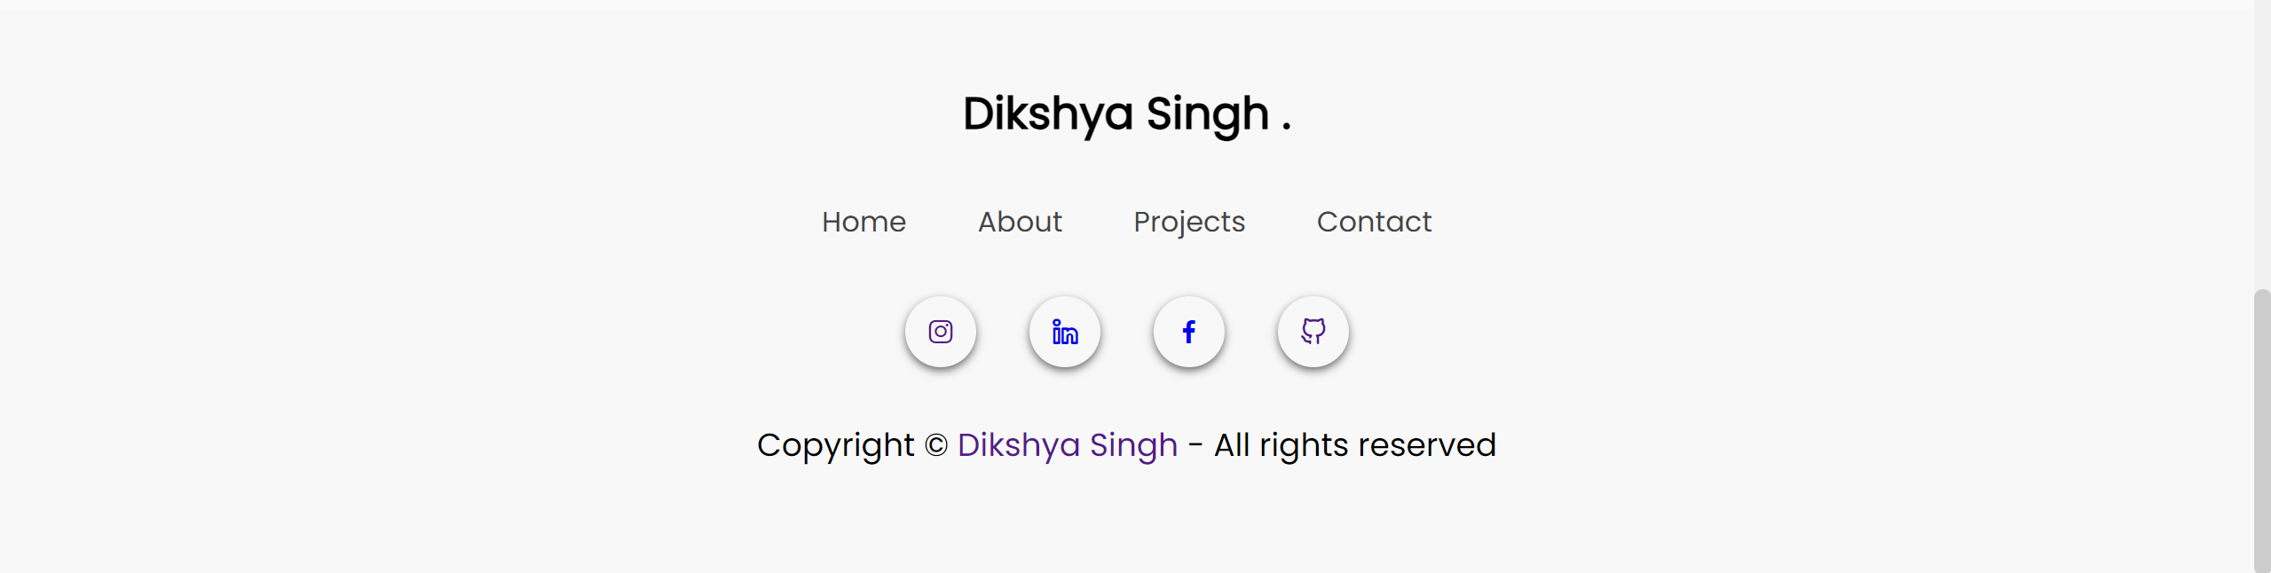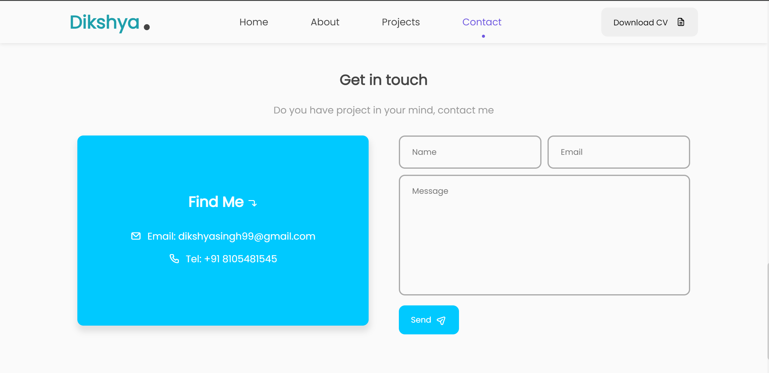

**Conclusion**

This project effectively developed a personal portfolio website featuring a responsive design, interactive elements, and engaging animations. The final website showcases skills and projects dynamically, providing a compelling user experience. Despite challenges such as performance optimization and cross-browser compatibility, the project meets its goals and delivers a professional platform for personal branding. Future improvements may involve further optimization and additional features to enhance user engagement.

**Thank You**